-:MECHANICAL STREAM:-

1. **WING**

Wing Span [S] = 30cms

Root length = 5.6cms

Tip length = 2cms

Fuselage Length = 21cms ….. (70% of Span )

CVT  = 0.05

CVH = 0.3

M.A.C = 6.366 …. (M.A.C=0.2*S*0.4244)

Area of Wing [A] = 114 cm2 ….. ( 5.6+2/2*30)

Tail arm moment = 11.55cm

1. **TAIL**

Vertical tail :-

Root length =2.7cms

Tip length = 2cms

Height = 4cms

Area = 9.4 cm2

Length of AC from tail to fuselag [LV]= 0.65cm

Horizontal tail :-

Root length = 2.7 cms

Tip length = 2 cms

Height = 4cms

Area = 9.4cm2

Length of AC from tail to fuselag [LH] =1.8cm

VEIWS OF 3D MODELING (SOFTWARE BASED – INVENTOR)

TOP VEIW :-

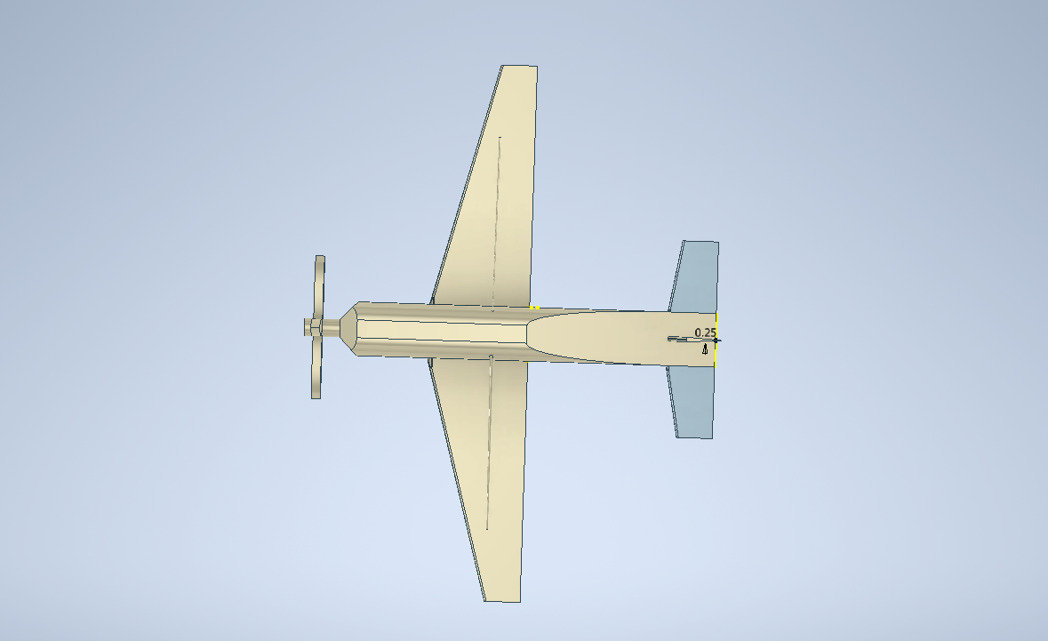

FRONT VEIW :-

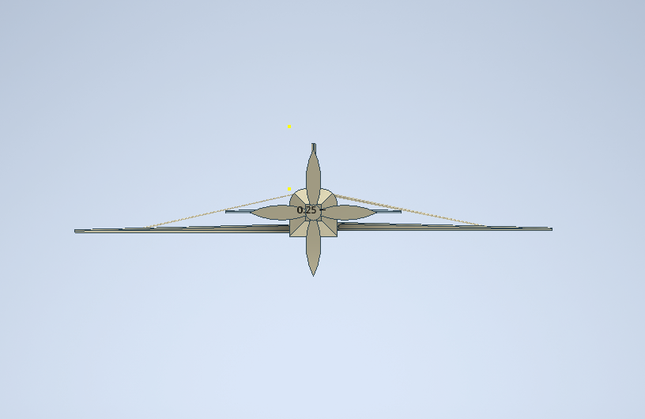

SIDE VEIW :-

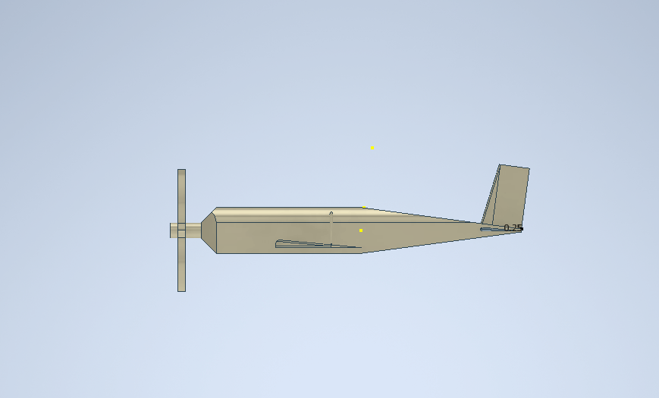

BACK VEIW:-

